TABLE OF CONTENTS

Angular #1

Section 1.1 #

Subsection 1.1.a #

Subsection 1.1.b #

Subsection 1.1.c #

Section 1.2 #

Section 1.3 #

Azure function app 21

Section 2.1 #

Section 2.2 #

Subsection 2.2.a #

Subsection 2.2.b #

Subsection 2.2.c #

Section 2.3 #

Chapter 3 #

Section 3.1 #

Section 3.2 #

Section 3.3 #

Subsection 3.3.a #

Subsection 3.3.b #

Subsection 3.3.c #

# Angular Installation

**Update the NPM to latest Version**

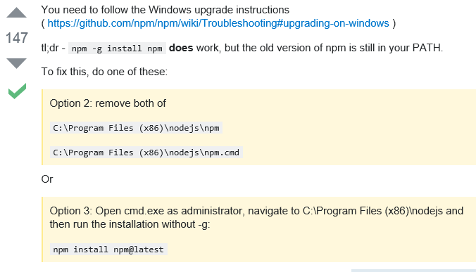

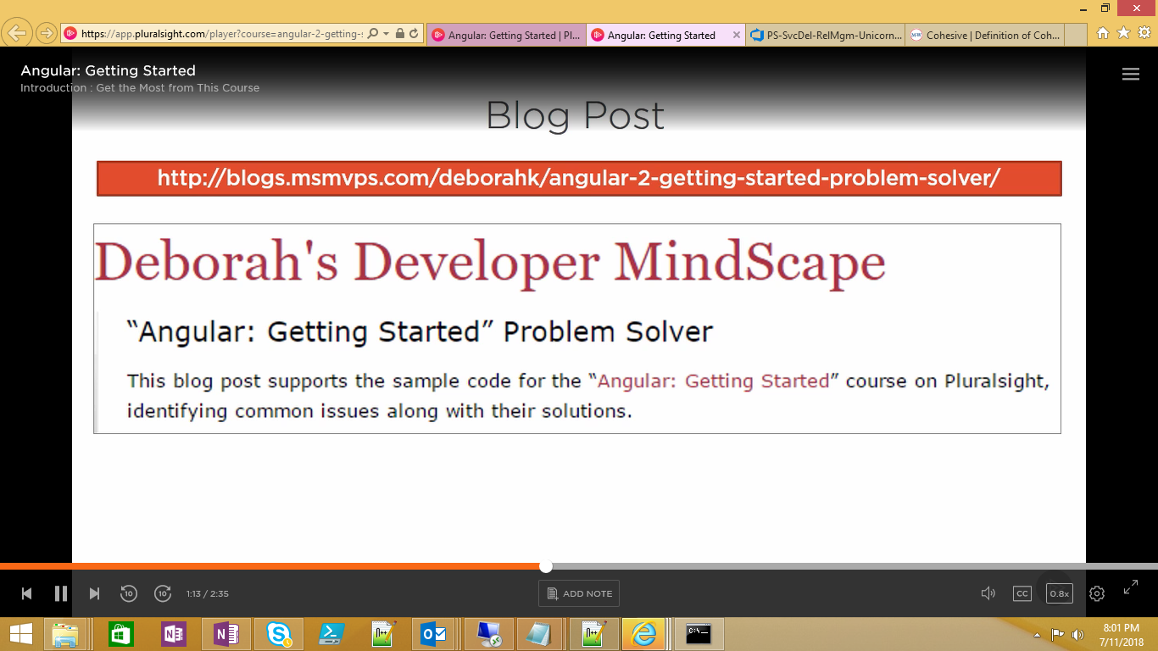

<https://blogs.msmvps.com/deborahk/angular-2-getting-started-problem-solver/>

<https://github.com/Deborahk/Angular-GettingStarted>

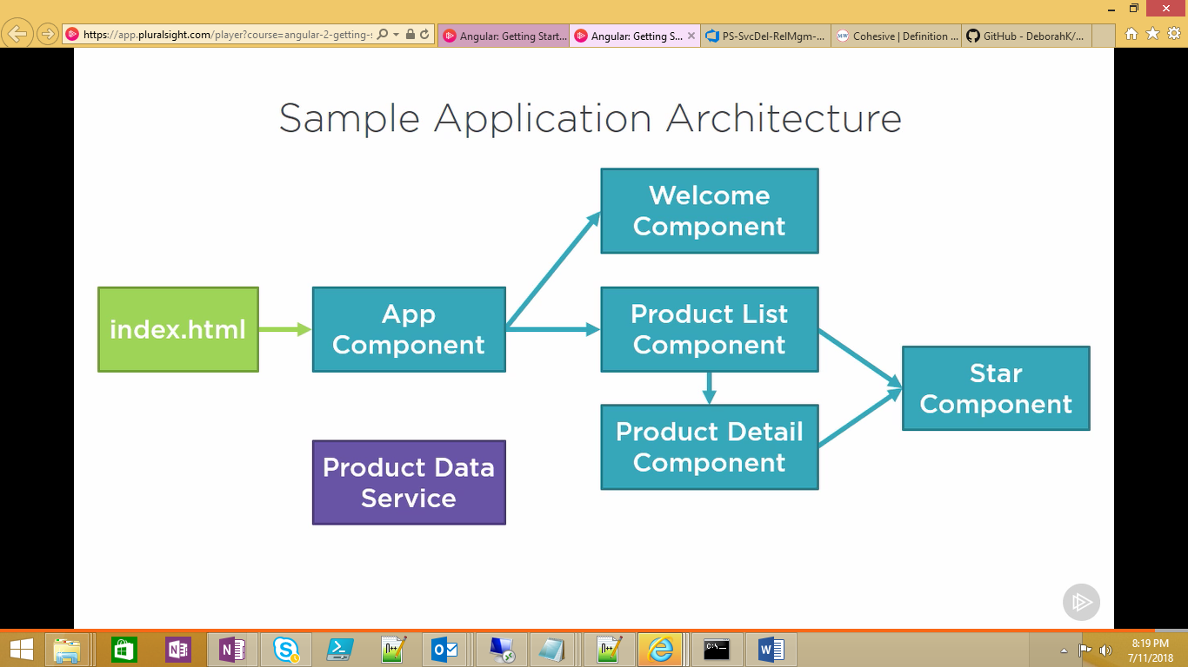

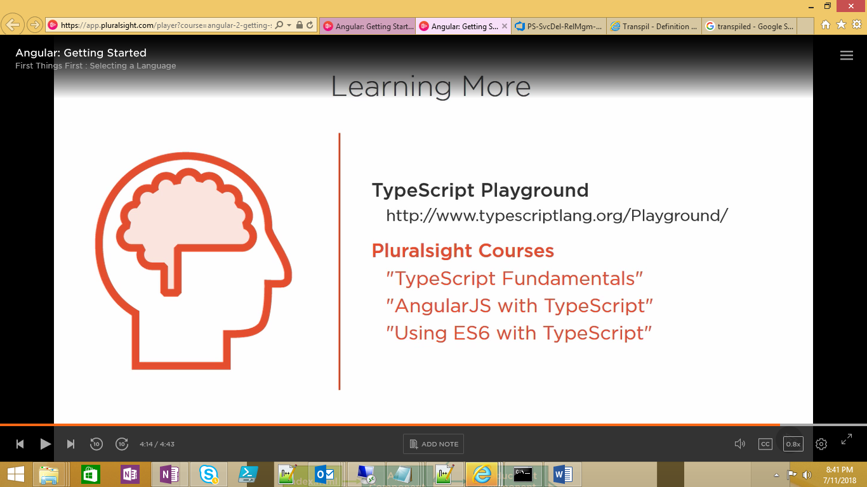

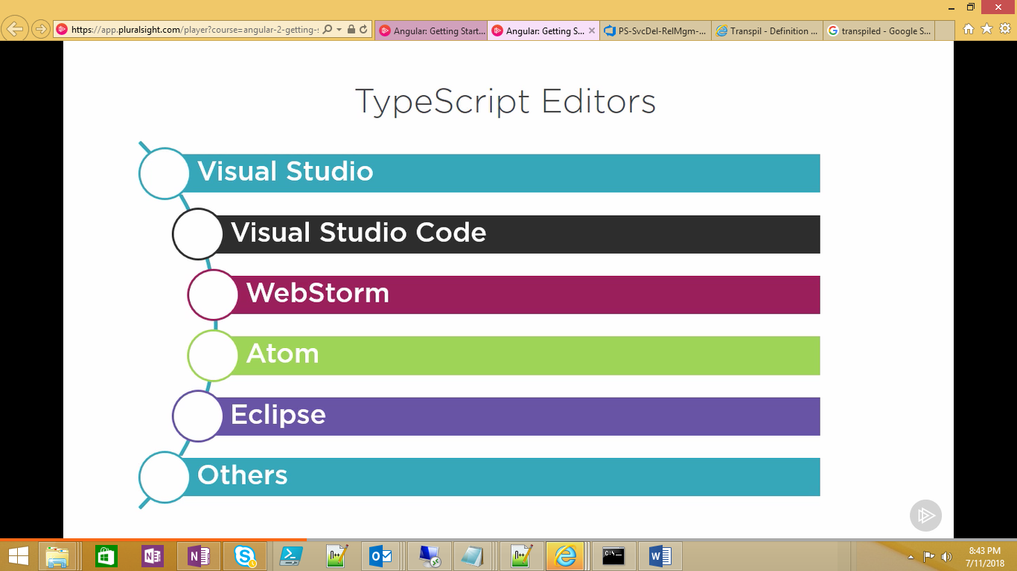

<https://code.Visualstudio.com>

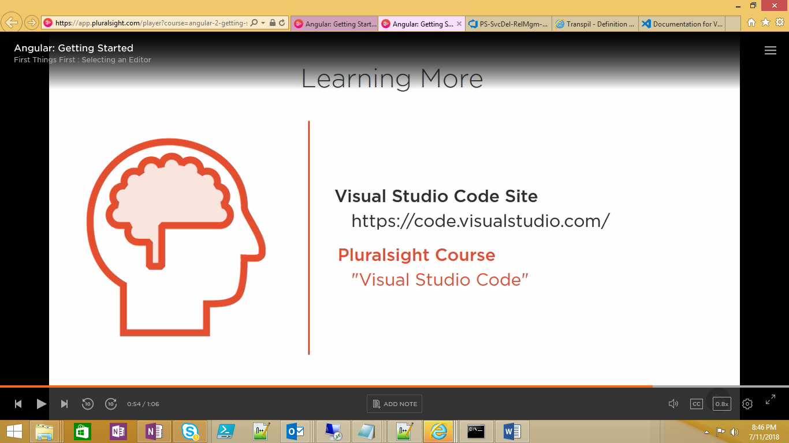

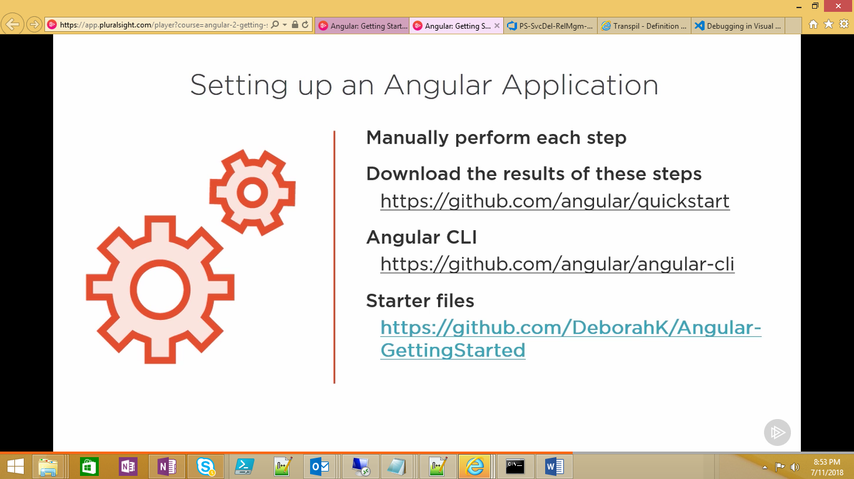

# AZURE Function APPAzur

Azure Functions Core Tools command line Interface

github.com/Azure/Azure-Functions-cli